**Course: High Performance Computing Lab**

**Practical No 1**

**PRN**: 23520006

**Name**: Vivek Katkar

**Batch**: B6

**Title** - Introduction to OpenMP

**Problem Statement 1** – Demonstrate Installation and Running of OpenMP code in C.

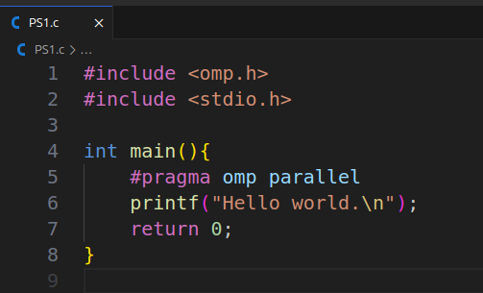

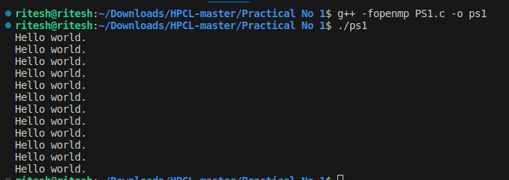

**Problem Statement 2** – Print ‘Hello, World’ in Sequential and Parallel in OpenMP

We first ask the user for number of threads – OpenMP allows to set the threads at runtime. Then, we print the Hello, World in sequential – number of times of threads count and then run the code in parallel in each thread.

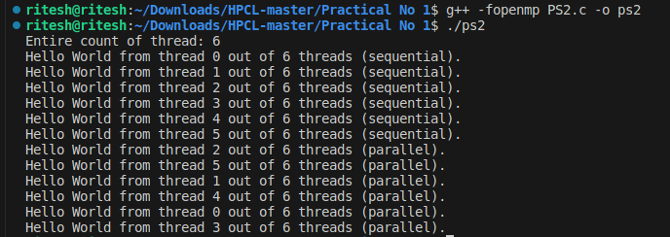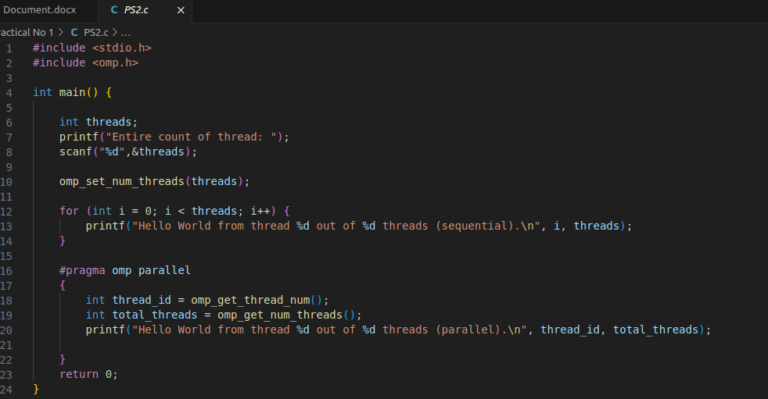**Code and output snapshot:**

**Problem statement 3**: Calculate theoretical FLOPS of your system on which you are running the above codes.

Elaborate the parameters and show calculation.

* ***Clock speed = 4.5 GHz***
* ***core = 6***
* ***FLOPs per cycle = 16***

***GFLOPSFLOPS=6×4.5×16= 432 GFLOPS***

**GitHub Link**: <https://github.com/vivekkatkar/HPCL>

**Conclusion :**

This practical introduced the basics of OpenMP, including installation, sequential vs. parallel execution, and runtime thread control. It also demonstrated how to calculate a system’s theoretical computational capacity in GFLOPS.